INSTALLATION INSTRUCTIONS
SERIES HANDLEBAR HEATERS

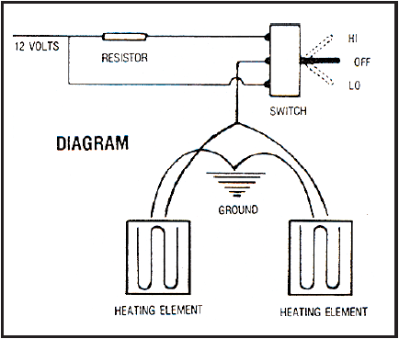
1) Remove grips. If you have rubber grips, heat them until they become flexible. Break the mastic by inserting a Phillips screwdriver between grip and handlebar, then pry
grip straight off. Do not attempt to twist off grip.

2) Remove all residues (glue, rubber, etc) from the area covered by grip on handlebar. Clean properly using either fine sandpaper or gasoline to obtain a residue free surface,
ready to receive the heating element.

3) Remove white contact protector from heating element. Encircle cleaned area with heating element, replace rubber grip on each side. Attach wires along control wire to pass underneath the hood

4) Drill a 1/2” diameter hole in dashboard for the installation of the HI-OFF-LO switch.

5) Take the wire from the heating element which is not connected to the switch and attach it to a suitable ground.

- ELECTRIC START MODELS:
Take a length of 18 gauge stranded wire and connect it to the end of the
single wire which extends from the “Y” junction and connect it to the
accessory lug on the rear of the snowmobile ignition switch.

- MANUAL START MODELS:
The wire mentioned in 5a must be connected to magneto (yellow wire) (+)

6) Choose the switch position for the desired function
- Up position for high heat
- Center - off
- Down position for low heat

NOTE: The lead on which the resistor is installed should be connected to the terminal which is located in front of the slot on the threaded portion of the switch in order to match the HI-OFF-LO switch.

7) Fasten wiring to steering column with electrical tape or a nylon tie wrap.

Thank you for choosing us for your snowmobiling needs.

